GETTING STARTED WITH ILLUMINATE

Logging into the System
http://help-dna.illuminateed.com/m/3670/l/17550-log-in-log-out-or-change-your-password

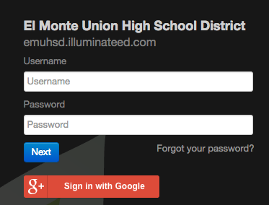
- Go to the website: https://emuhsd.illuminateed.com
- Type in your username and password
- Click on the red g+ sign in with Google box
4. Click on your district email address that appears

Getting Help When You Need it

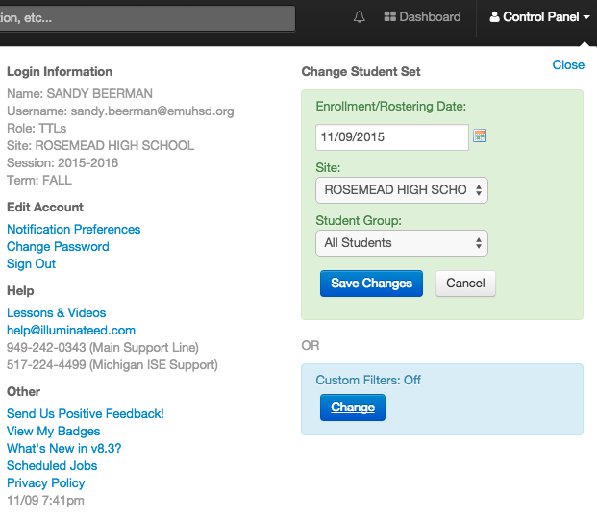
Click on “control panel” in the top right corner of the screen.

Under the “Help” heading on the left you will see there is a
link to view all Lessons & videos to help you under-
stand using the system. You can also click on the
email address listed to send your question to the
company for further assistance.

Understanding Where to Begin

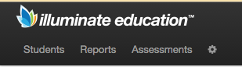
To access the main menu for all your assessment needs,

you will click on the items in the top left side

of the screen.

Anytime you wish to return to the main page when using

Illuminate simply click on “Dashboard” in
top right corner of the screen, you will be
brought back to the main page.

Getting Started with Assessment:

Assessment Introduction Overview
http://help-dna.illuminateed.com/m/2974/l/17308-introduction-to-assessments

Assessment Quick Start 1 page
http://help-dna.illuminateed.com/m/5500/l/51943-quick-guide-create-assessments

Assessments - creating on the fly, manual setup and hybrid assessments (link below is for all 3 listed)
http://help-dna.illuminateed.com/m/10241/l/190926-u310-creating-on-the-fly-manual-and-hybrid-assessments

1. To print out a scan sheet:
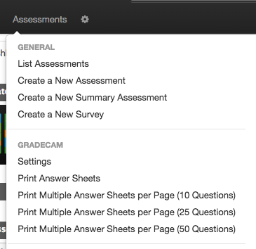
From your Dashboard, click on “Assessments”
Select “Print Answer Sheets” from the
drop down menu that appears.

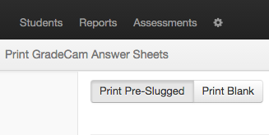
To print an answer document with the student
names pre-filled click on “Print Pre-Slugged”
on the top left corner.

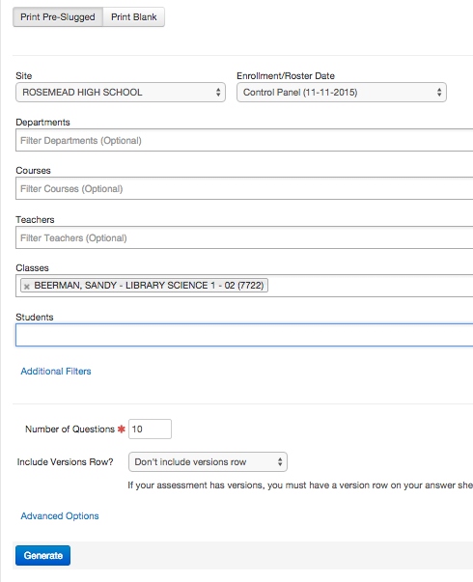

Complete those areas that you wish (most are listed
as “optional”). The more you complete the
better complete the answer document will
become

Enter the number of questions you wish to appear
on the document.

Click “Generate”

To print a generic document (students must
bubble their name and ID number),
click “Print Blank” on the top left
corner.

Enter the number of questions you wish to appear
on the document.

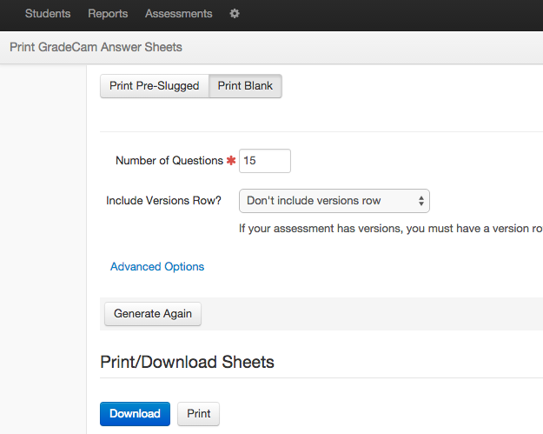
Click “Generate”

- Creating a Test “On the Fly” (exit ticket) - items used to assess students' progress and/or mastery at the time of instruction.

NOTE: You need a document camera or web camera for this GradeCam-related action
http://help-dna.illuminateed.com/m/2974/l/17314-creating-an-on-the-fly-assessment

On The Fly means you will scan right now with no standards aligned (you can always save the results and align standards later).

It is recommended that you have some generic scan sheets always on hand so that you can have students complete an “on the fly” test at anytime. The company stated that you can even give each of your students an answer key with 10 questions (if that is the most you will ever ask students to complete for an exit ticket) and put it in a plastic sleeve. Students can use an erasable marker to mark their answers and reuse the same answer document multiple times in your class.

Unlike EADMs the answer sheets can be used with any assessment, the assessment is no longer tied to a specific answer sheet. In addition, there doesn’t need to be a one-to-one relationship between number of questions and number of answer rows, you can ask students to bubble in only 5 questions on a scan sheet with 10 slots.

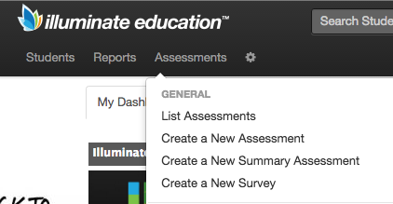
Click on the top left corner of the screen on “assessment”
Select “Create a New Assessment”

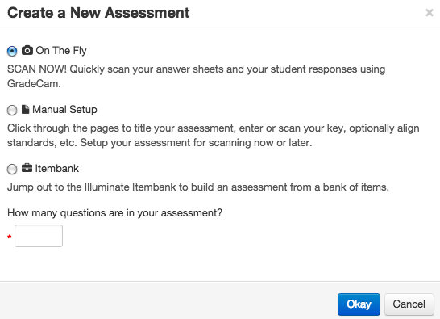
Select “On the Fly” by clicking on the button to the left,
Type in the number of questions you want to
have on the assessment at the bottom of
the box.

Click “okay”

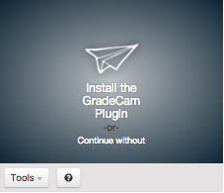

On the box that appears to the left it states
“Install the GradeCam Plugin
You should install this (will only have to do it once) your
machine will need to be restarted.

NOTE: you may need to click the Tools link to choose
the document camera or change settings
(e.g., to "flip" the image if it shows upside down).

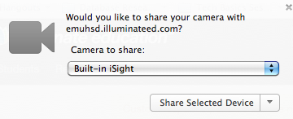
If you are asked to share a camera click “Share Selected Device”

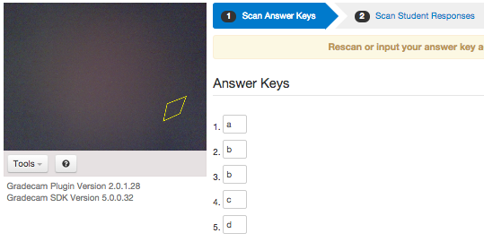
To create the answer key use one of the printed bubble

answer sheets you made earlier and bubble in

the answer key for those questions you will give

to your students.

(it is okay if you have rows that are not used and
are left blank by students – these will not
count against students).

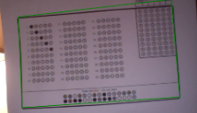
Hold the answer key up to the camera allowing the entire
page to be viewed in the box to the left. When the answer
document is surrounded in a green square you will get a
box appear on the Illuminate page stating the answer key
has been successfully scanned.

A message will appear that your answer key has been
successfully scanned.
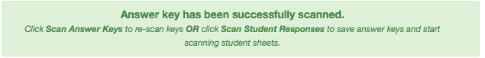

Scanning the student response document

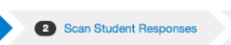
Click on “2 Scan Student Responses” at
the top of the page.

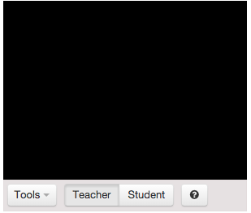
You will now notice that the box has changed

slightly and it now states “Teacher” “Student”

at the bottom.

If you are having students scan their own

answer documents, click on

“Student”. Your student will now hold

their answer document up to the camera and

they will see their own score immediately

on the right.
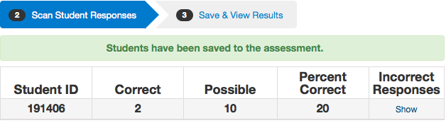

If you are scanning the student document

for them yourself, you will click on “Teacher”

and hold each student answer document up

to the camera. As you scan the document

you will see all student answers display

on the right.
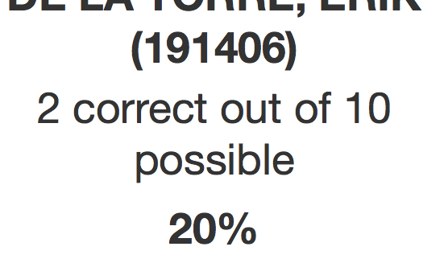

Hold the completed answer sheet up to the
camera and scan the answers into the system.

To troubleshoot your scanning go to http://help-dna.illuminateed.com/m/4830/l/96914-my-answer-sheet-is-not-scanning

3. Creating a Manual Setup -

- Manual Setup is not an itembank assessment using pre-constructed items, but an assessment that is already completed and users have the answer key or information ready in-hand

- Examples would include teacher-made quizzes, curriculum assessments,
http://help-dna.illuminateed.com/m/2974/l/239088-creating-a-manual-assessment

Click on the top left corner of the screen on “assessment”
Select “Create a New Assessment”

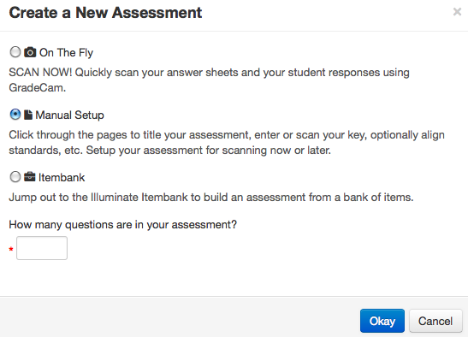
Select “Manual Setup” by clicking on the button to the left,

Type in the number of questions you want to
have on the assessment at the bottom of
the box.

Click “okay”

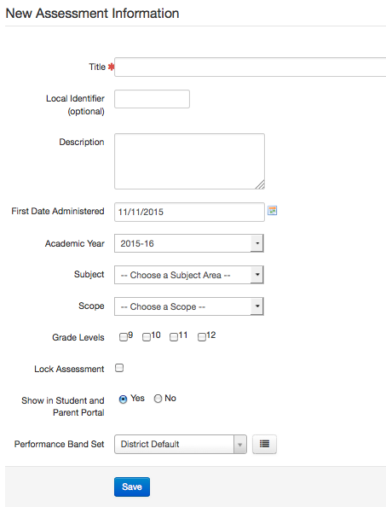
Complete as much information as you would like, “*”
is required.

At the top of the page you will now see the sub-navigation menu
Allowing you to perform various functions for this test.

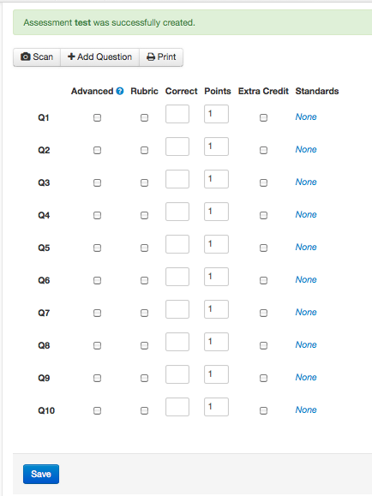
Enter in the answers as well as the points for each question
for your assessment in your answer key.

Click “Save”
A green banner will appear at the top stating
questions have been saved successfully.

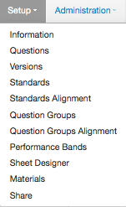
Click on “Setup” to perform additional functions such as add standards

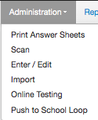
Click on “Administration” in the sub-navigation tab and choose “Print Answer Sheets”

Print Answer Sheets -

To print an answer document with the student
names pre-filled click on “Print Pre-Slugged”
on the top left corner.

Complete those areas that you wish (most are listed
as “optional”). The more you complete the
better complete the answer document will
become

Enter the number of questions you wish to appear
on the document.

Click “Generate”

To print a generic document (students must
bubble their name and ID number),
click “Print Blank” on the top left
corner.

Enter the number of questions you wish to appear
on the document.

Click “Generate”

Scanning the student answer sheet:

Click on “Administration” in the sub-navigation tab and choose “Scan”

On the box that appears to the left it states
“Install the GradeCam Plugin
You should install this (will only have to do it once) your
machine will need to be restarted.

NOTE: you may need to click the Tools link to choose
the document camera or change settings
(e.g., to "flip" the image if it shows upside down).

If you don’t have time to install currently you can click
“Continue without”, you will be able to scan and
install the plugin later. Note: you will not need the
tech to install it does not require a password.

If you are asked to share a camera click “Share Selected Device”

You will now notice that the box has changed

slightly and it now states “Teacher” “Student”

at the bottom.

If you are having students scan their own answer

documents, click on “Student”. Your student

will now hold their answer document up to

the camera and they will see their own score

immediately on the right.

If you are scanning the student document for them

yourself, you will click on “Teacher” and hold

each student answer document up to the camera.

As you scan the document you will see all

student answers displayon the right.
Hold the completed answer sheet up to the camera and scan the answers into the system.
PROPER SCANNING CONDITIONS:
- Image must be right side up in the preview window (image can not be placed upside down).
- Answer document must fill the preview window - not a lot of white space visible.
- Black Rectangle around answer document should be visible in the preview window to scan (all four corners must be visible to get a good scan) – this allows the scan to be set correctly for proper scanning. There should not be any gaps or spaces in the black rectangle.
- No student writing inside the black rectangle, only bubbling the answers within the proper area to bubble.
- Make sure the camera is in focus.
- You should not have any glare or reflection in the preview window for the scan (may have to change the lighting in your room). There should have good contrast between page and student answer that is bubbled.
- Preferred browser is current version of Firefox or Chrome.

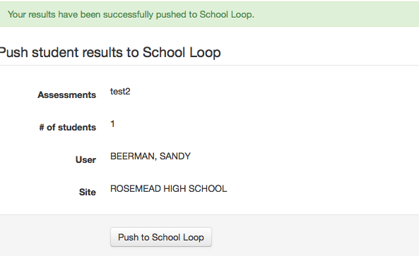
Importing Grades from Illuminate into School Loop

FROM WITHIN ILLUMINATE

Click on “Assessments” from your dashboard

Select “Push to School Loop”

Click on “Push to School Loop” button at the

bottom of the page

FROM WITHIN SCHOOL LOOP

It only takes a few moments before scores sent to your School Loop Gradebook are ready for processing. Look for the alert in the right column of your School Loop portal.

Log into your School Loop account

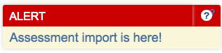
You should now see an alert box on the right hand

side of your dashboard

Click on “Assessment import is here!”

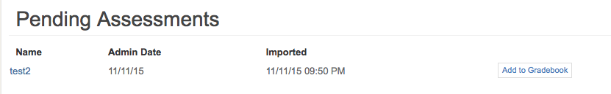
Click on “Add to Gradebook”

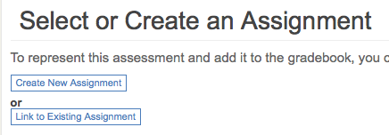
Click either “Create New Assignment” or
“Link to Existing Assignment”

Create New Assignment
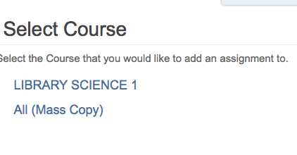
Select the course you would like to add the data

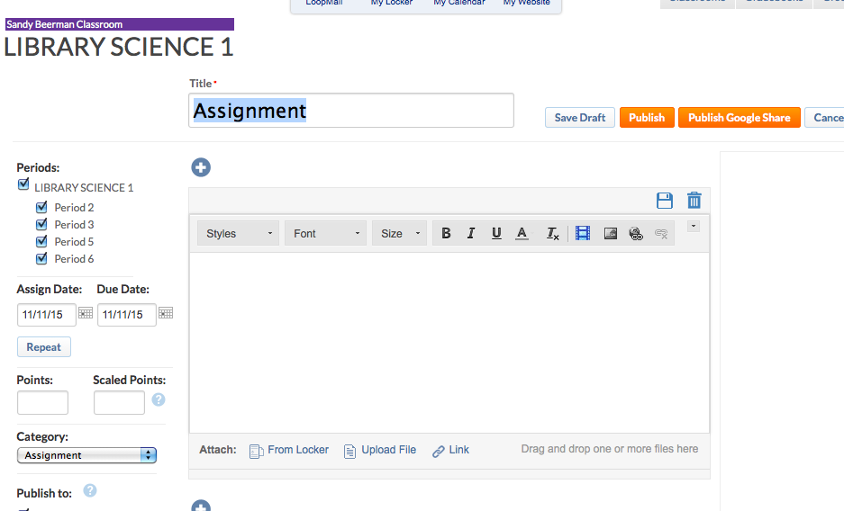
Enter the test into School Loop like usual

You should now see “Success! Assessment grades added to gradebook
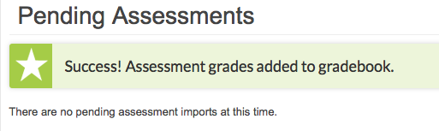

Link to Existing Assignment

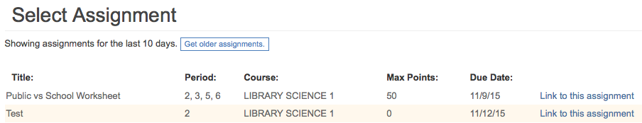
Click “Link to this assignment” to the right of the assignment you would like to have the data linked.

You should now see “Success! Assessment grades added to gradebook.

Grading an Assessment: (http://help-dna.illuminateed.com/m/4830?data-resolve-url=true&data-manual-id=4830)

Paper/pencil Grading with GradeCam or other Scanning Options
http://help-dna.illuminateed.com/m/4830/l/70909-video-scanning-101

Online Testing Administration
http://help-dna.illuminateed.com/m/10241/l/167864-u350-online-testing-administration

